Name: Trần Bình Trọng
Student Number: 2231200121
CSW 434 – Lab 1: Group Chat App with Real-Time Feature using Socket
Link Github: Click here to go to github
Note:
Please change the value of SOCKET_URL in “./services/socket.ts” with your IPv4 address before testing!
Use 1st terminal type: cd server -> node server.js
Use 2nd terminal type: npx expo start
Connect to your real device and virtual device to test

Home Screen: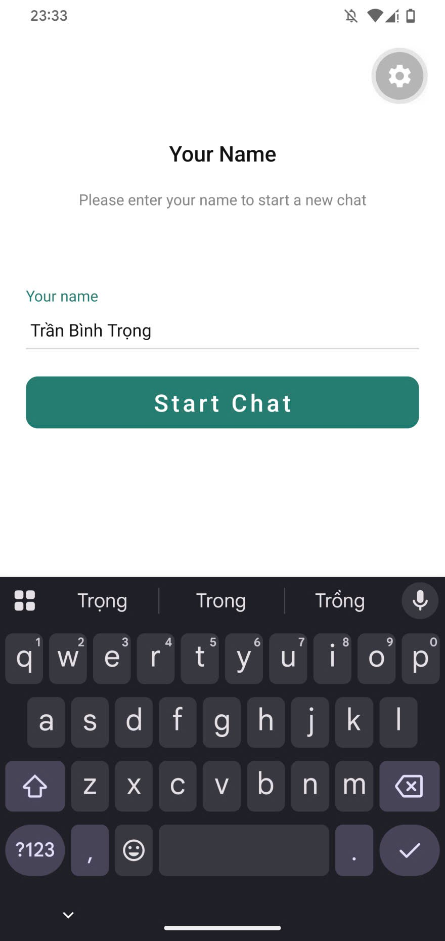
Group Screens - Chatting:
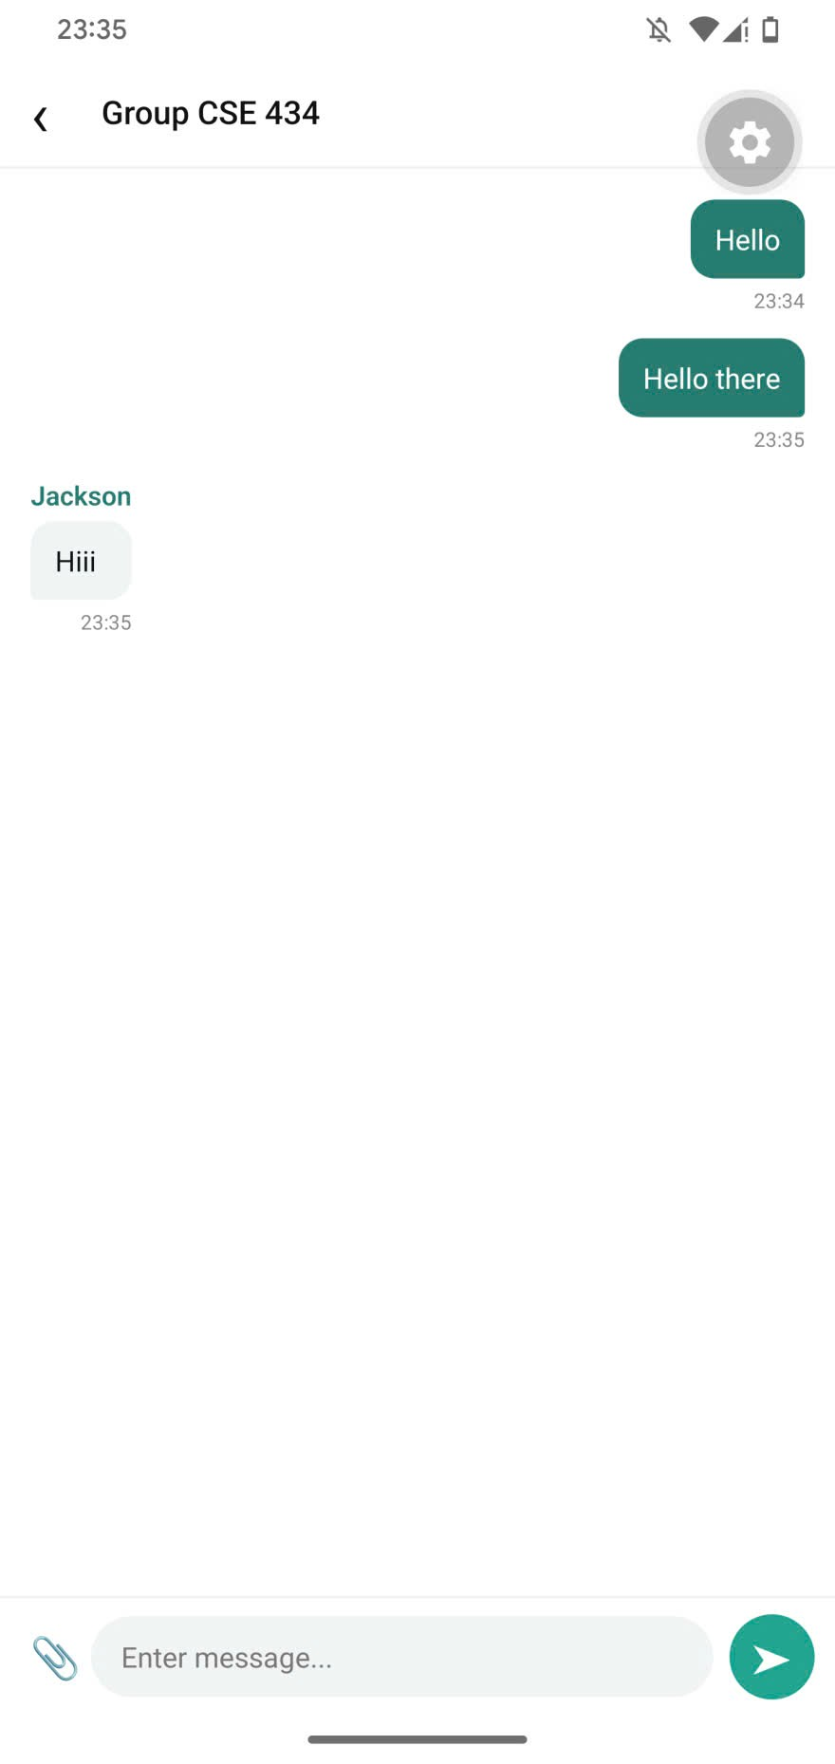 (From real mobile device)
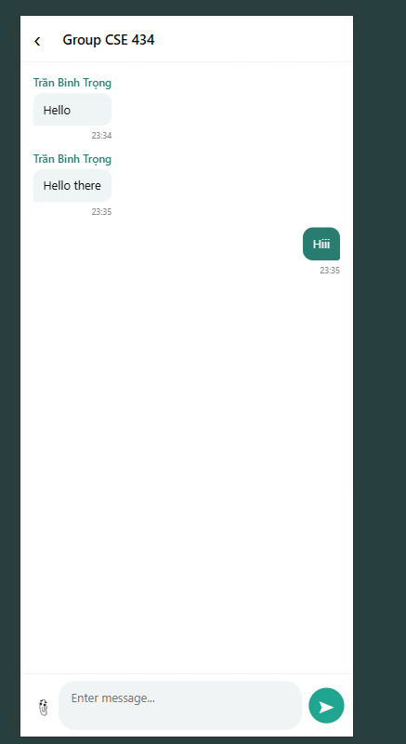 (From web - testing version – Another device)

